SmartDevice Test Analysis
Class under test: SmartDevice. JUnit tests go in SmartDeviceTest.java
Note: SmartDevice has no if/switch statements and no loops. Every method runs straight through, so each method has exactly one path.

1. Control Flow Graphs
Node numbers: each statement in the class gets one number, counted across the whole class, so no number is used twice. Start and End are not numbered. The rest of this document refers to statements by these numbers.
Node | Method | Statement
1 | Constructor | this.deviceId = deviceId
2 | Constructor | this.roomName = roomName
3 | Constructor | this.type = type
4 | Constructor | this.status = status
5 | getDeviceId() | return deviceId
6 | getRoomName(). | Return roomName
7 | getType | return type
8 | isStatus() | return status
9 | setStatus() | this.status = status

Constructor

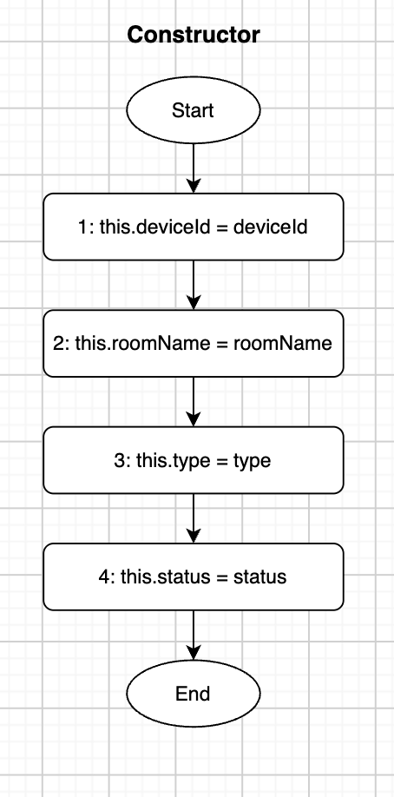

Getters
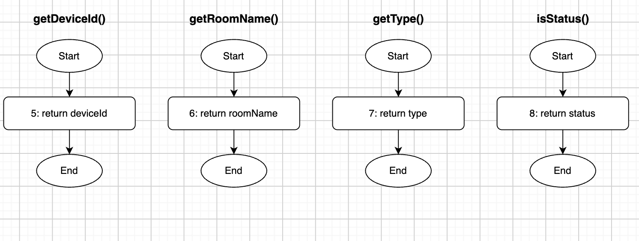

setStatus
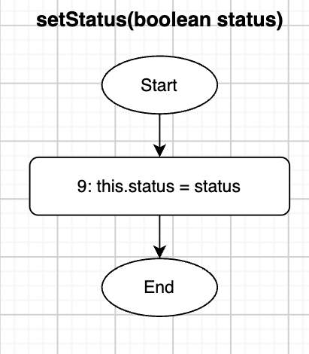

2. Statement Coverage
Goal: run every statement (nodes 1–9) at least once.
ID | Input | Expected output | Path (nodes)
TC1 | new SmartDevice("D01", "Kitchen", LIGHTING, true), then call all four getters | "D01", "Kitchen", LIGHTING, true | 1→2→3→4→5→6→7→8
TC2 | Device created with status true, then setStatus(false) | isStatus() returns false | 1→2→3→4→9→8
TC3 | Device created with status false, then setStatus(true) | isStatus() returns true | 1→2→3→4→9→8
TC1 covers nodes 1–8 and TC2 covers node 9 → 100% statement coverage.

3. Branch Coverage
Not applicable. The class has no decisions (if, switch, ?:), so there are no true/false branches.

4. Loop Coverage
Not applicable. The class contains no loops.

5. Path Coverage
Each method runs straight from Start to End, so each has exactly one path.
Method | Path (nodes) | Covered by
Constructor | 1→2→3→4 | TC1
getDeviceId() | 5 | TC1
getRoomName() | 6 | TC1
getType() | 7 | TC1
isStatus() | 8 | TC1
setStatus() | 9 | TC2, TC3
All paths covered → 100% path coverage.

6. Data-Flow Testing
There are no predicate uses (p-uses) because there are no decisions. Every use is a computational use (c-use): a getter returning the field.
Variable | Def (node) | C-use (node) | DU pair | Covered by
deviceId | 1 | 5 | (1, 5) | TC1
roomName | 2 | 6 | (2, 6) | TC1
type | 3 | 7 | (3, 7) | TC1
status | 4 | 8 | (4, 8) | TC1
status | 9 | 8 | (9, 8) | TC2, TC3
All DU pairs covered.

7. Equivalence Class Partitioning (ECP)
Input | Equivalence classes | Test case
type | HVAC, LIGHTING, SECURITY, APPLIANCE (one class each) | TC4
status | true, false | TC1 (true), TC3 (false)
deviceId / roomName | Normal non-empty text | TC1
deviceId / roomName | Empty string or null | TC5
New test cases:
ID | Input | Expected output
TC4 | Create one device for each type: HVAC, LIGHTING, SECURITY, APPLIANCE | getType() returns the same type each time
TC5 | new SmartDevice("", null, HVAC, false) | getDeviceId() returns "", getRoomName() returns null (the class does not validate input)

8. Boundary Value Analysis (BVA)
Not applicable. There are no numeric inputs or ranges. status is a boolean and type is an enum, so there are no boundaries to test beyond the classes in Section 7.

SmartHomeHub Test Analysis
Class under test: SmartHomeHub. JUnit tests go in SmartHomeHubTest.java.

1. Control Flow Graphs
Node numbers: each statement or decision in the class gets one number, counted across the whole class, so no number is used twice. Start and End are not numbered.
The constructor's if has three conditions joined by ||. Java stops at the first one that is true (short-circuit), so each condition is drawn as its own decision node (1, 2, 3).
Node | Method | Statement
1 | Constructor | connectedDevices == null (decision)
2 | Constructor | connectedDevices.isEmpty() (decision)
3 | Constructor | connectedDevices.size() > 50 (decision)
4 | Constructor | throw new IllegalArgumentException(...)
5 | Constructor | this.connectedDevices = connectedDevices
6 | Constructor | this.energyTariff = new EnergyTariff()
7 | Constructor | this.automationRule = new AutomationRule()
8 | computeTotalSystemBill() | return energyTariff.calculateBill(totalKWh)
9 | checkSystemEmergencyStatus() | return automationRule.evaluateEmergencyCoolingTrigger(reading)
10 | getActiveDeviceCount() | int count = 0
11 | getActiveDeviceCount() | for (SmartDevice device : connectedDevices) (loop decision: another device?)
12 | getActiveDeviceCount() | if (device.isStatus()) (decision)
13 | getActiveDeviceCount() | count++
14 | getActiveDeviceCount() | return count

Constructor
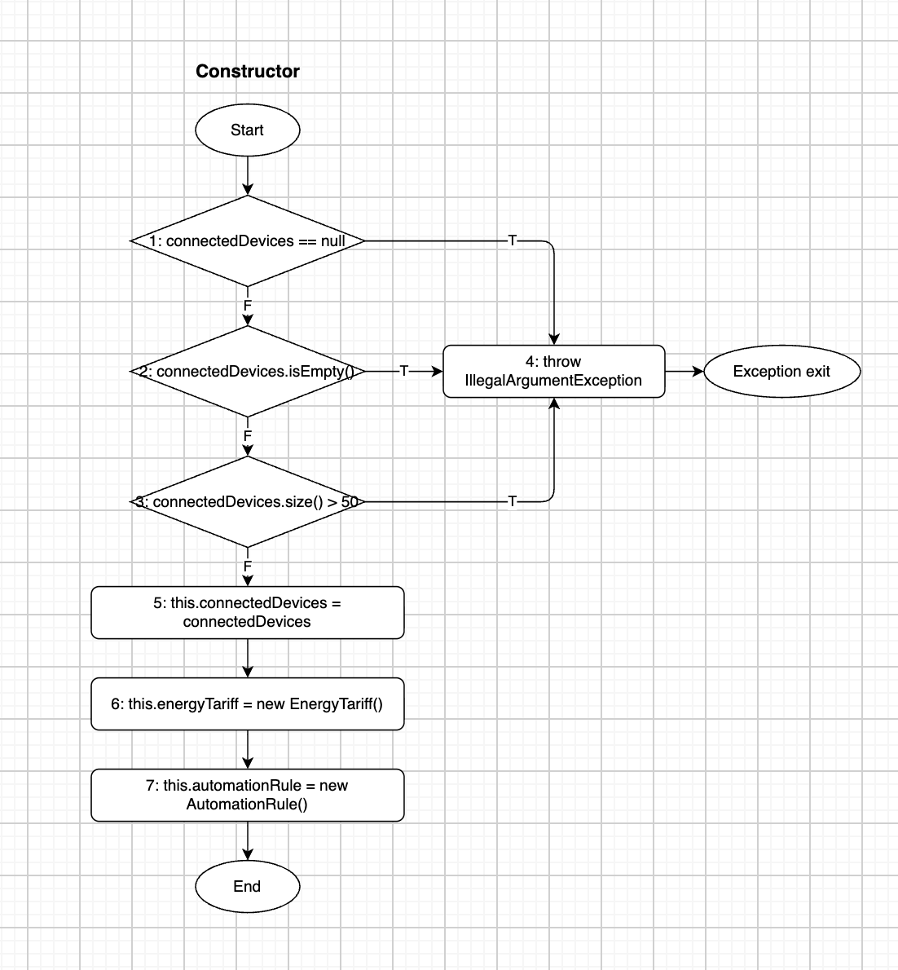

computeTotalSystemBill
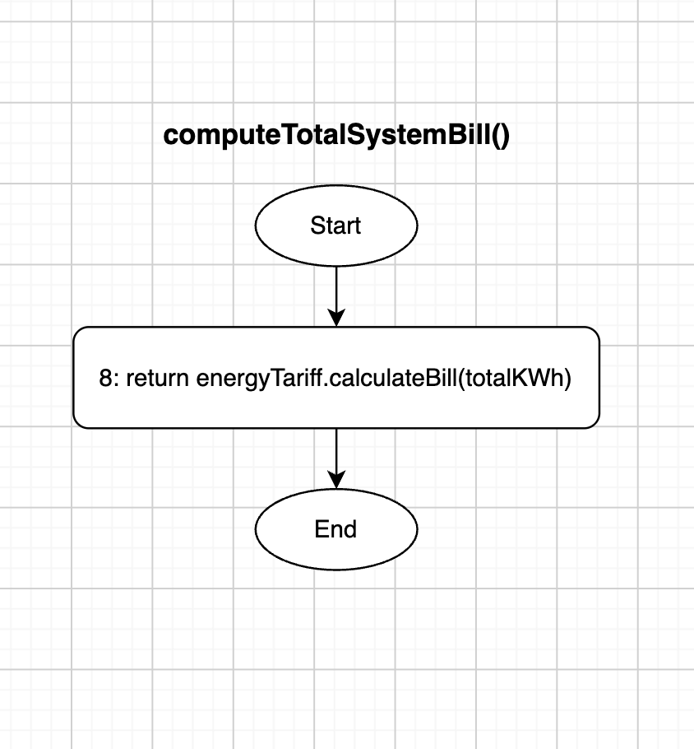

checkSystemEmergencyStatus
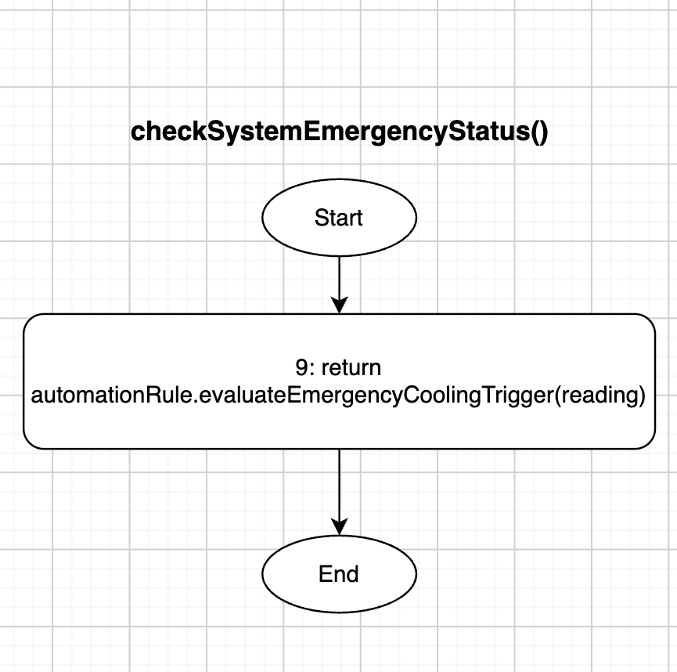

getActiveDeviceCount
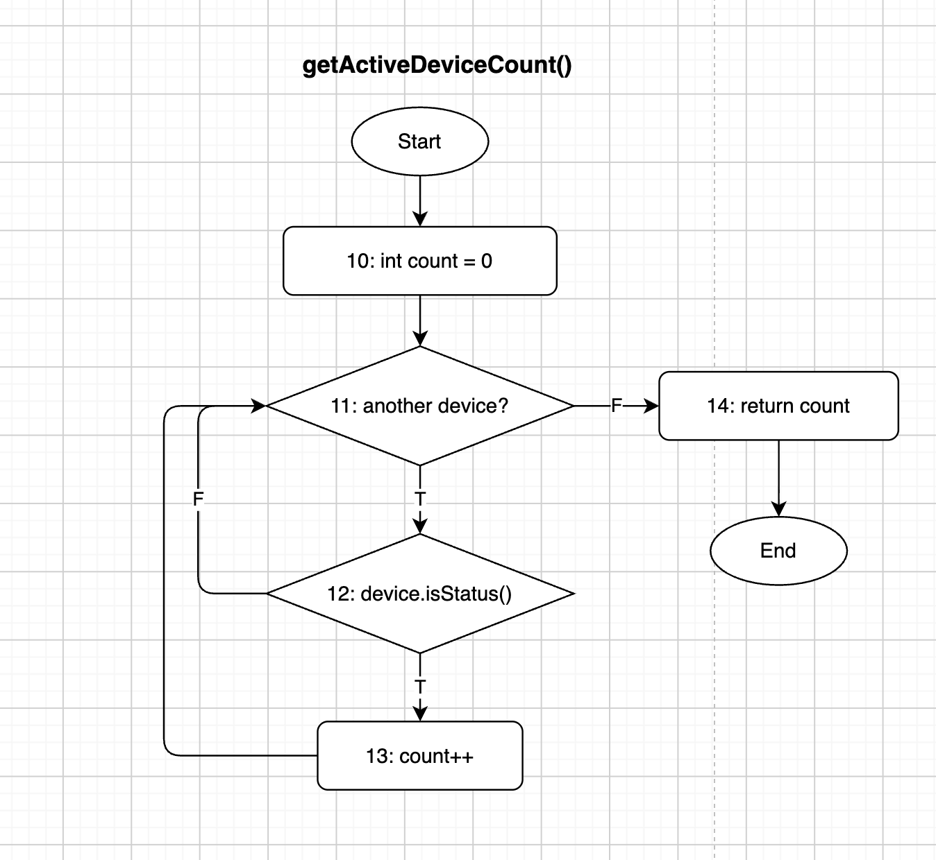

Test Cases
All test cases are listed once here. Each later section says which ones it uses. A path follows the order the test calls the methods; a comma means the next method call.
ID | Input | Expected output | Path (nodes)
TC1 | new SmartHomeHub(null) | IllegalArgumentException | 1→4
TC2 | Empty list (0 devices) | IllegalArgumentException | 1→2→4
TC3 | List of 51 devices | IllegalArgumentException | 1→2→3→4
TC4 | List of 1 device (ON), then getActiveDeviceCount() | Hub created; count = 1 | 1→2→3→5→6→7, 10→11→12→13→11→14
TC5 | List of 2 devices (ON, OFF), then getActiveDeviceCount() | count = 1 | 1→2→3→5→6→7, 10→11→12→13→11→12→11→14
TC6 | List of 25 devices (10 ON, 15 OFF), then getActiveDeviceCount() | count = 10 | Constructor as TC4, loop runs 25 times
TC7 | List of 49 devices (all OFF), then getActiveDeviceCount() | count = 0 | Constructor as TC4, 10→(11→12)×49→11→14
TC8 | List of 50 devices (all ON), then getActiveDeviceCount() | count = 50 | Constructor as TC4, 10→(11→12→13)×50→11→14
TC9 | Hub created with 1 device, then the original list is cleared, then getActiveDeviceCount() | count = 0 | Constructor as TC4, 10→11→14
TC10 | Hub with 1 device, computeTotalSystemBill(250) | Same value as new EnergyTariff().calculateBill(250) | Constructor as TC4, 8
TC11 | Hub with 1 device, checkSystemEmergencyStatus(r) with a reading that triggers cooling | true, same as AutomationRule | Constructor as TC4, 9
TC12 | Hub with 1 device, checkSystemEmergencyStatus(r) with a normal reading | false, same as AutomationRule | Constructor as TC4, 9
For TC11 and TC12, take the reading values from the AutomationRule analysis so both classes use the same data.

2. Statement Coverage
Goal: run every node (1–14) at least once.
Test case | New nodes covered
TC1 | 1, 4
TC4 | 2, 3, 5, 6, 7, 10, 11, 12, 13, 14
TC10 | 8
TC11 | 9
TC1 + TC4 + TC10 + TC11 → 100% statement coverage.

3. Branch Coverage
Goal: take both the true (T) and false (F) edge of every decision (nodes 1, 2, 3, 11, 12).
Decision | True edge | False edge
1: connectedDevices == null | TC1 | TC2
2: isEmpty() | TC2 | TC3
3: size() > 50 | TC3 | TC4
11: another device? | TC4 | TC4
12: device.isStatus() | TC4 | TC5
TC1–TC5 → 100% branch coverage. Because each || condition is its own node, this also gives full condition coverage.

4. Loop Coverage
The only loop is the for loop in getActiveDeviceCount() (node 11). The list size is limited to 1–50 by the constructor.
Iterations | Test case
0 (skip the loop) | TC9
1 | TC4
2 | TC5
Typical (25) | TC6
Maximum − 1 (49) | TC7
Maximum (50) | TC8
Maximum + 1 (51) | Not reachable: the constructor rejects it (TC3)
Zero iterations: the constructor rejects an empty list, but it stores the caller's list without copying it. Clearing that list after construction makes the loop run 0 times (TC9). See Observations.

5. Path Coverage
Constructor: 4 paths, all covered.
Path | Test case
1→4 | TC1
1→2→4 | TC2
1→2→3→4 | TC3
1→2→3→5→6→7 | TC4
computeTotalSystemBill() and checkSystemEmergencyStatus(): one path each (8 and 9), covered by TC10 and TC11/TC12.
getActiveDeviceCount(): the number of paths depends on how many devices there are and which are ON, so every path cannot be tested. We cover the basis paths (cyclomatic complexity = 2 decisions + 1 = 3):
Basis path | Test case
10→11→14 (loop skipped) | TC9
10→11→12→13→11→14 (device ON) | TC4
10→11→12→11→…→14 (device OFF) | TC5, TC7

6. Data-Flow Testing
Definitions and uses
Variable | Def (node) | C-use (node) | P-use (node)
connectedDevices (parameter) | Constructor start | 5 | 1, 2, 3
this.connectedDevices (field) | 5 | 11 | —
energyTariff | 6 | 8 | —
automationRule | 7 | 9 | —
count | 10, 13 | 13, 14 | —
device | 11 | — | 12
totalKWh | Method start | 8 | —
reading | Method start | 9 | —

DU pairs
Variable | DU pair | Covered by
connectedDevices (parameter) | (start, 1), (start, 2), (start, 3), (start, 5) | TC1, TC2, TC3, TC4
this.connectedDevices | (5, 11) | TC4
energyTariff | (6, 8) | TC10
automationRule | (7, 9) | TC11
count | (10, 13): first ON device | TC4
count | (10, 14): no device ON | TC7, TC9
count | (13, 13): two ON devices in a row | TC8
count | (13, 14): last change reaches the return | TC4
device | (11, 12) with both outcomes of 12 | TC4 (T), TC5 (F)
totalKWh | (start, 8) | TC10
reading | (start, 9) | TC11
All DU pairs covered.

7. Equivalence Class Partitioning (ECP)
Variant: weak robust (from the testing plan).
Input | Class | Valid? | Test case
Device list | null | Invalid | TC1
Device list | Empty | Invalid | TC2
Device list | 1–50 devices | Valid | TC4
Device list | More than 50 devices | Invalid | TC3
Device statuses | All ON | Valid | TC8
Device statuses | All OFF | Valid | TC7
Device statuses | Mixed | Valid | TC5, TC6
Sensor reading | Triggers cooling | Valid | TC11
Sensor reading | Does not trigger cooling | Valid | TC12
totalKWh | Valid consumption | Valid | TC10
The kWh and sensor-reading classes are tested in full in EnergyTariff and AutomationRule. Here we only check that the hub passes the input along and returns the result.

8. Boundary Value Analysis (BVA)
Variant: robust BVA on the device-list size (valid range 1–50).
Value | Meaning | Expected | Test case
0 | min − 1 | IllegalArgumentException | TC2
1 | min | Hub created | TC4
2 | min + 1 | Hub created | TC5
25 | nominal | Hub created | TC6
49 | max − 1 | Hub created | TC7
50 | max | Hub created | TC8
51 | max + 1 | IllegalArgumentException | TC3
The kWh boundaries (0, 100, 500, 10,000) are tested in EnergyTariff, not repeated here.

Observations
- The device list is not copied. The constructor checks the list, then stores the caller's reference. Adding or removing devices afterwards bypasses the 1–50 check. TC9 shows this.
- A null device inside the list passes the constructor, but getActiveDeviceCount() then throws NullPointerException at node 12.
- Dependencies can't be replaced. The hub creates its own EnergyTariff and AutomationRule, so tests use the real classes (integration testing) instead of test doubles.

